

# PROJECT: Coffee & Cake GROUP NO: ......04 BATCH: ....T1.2206.E1

# A. SYSTEM REQUIREMENTS:

|  |  |  |
| --- | --- | --- |
| **Sr.** | **Item** | **Description** |
| 1. | Operating system | Windows 7, 8, or higher |
| 2. | Hardware | CPU Cores or better with 2 Gigabytes of RAM or better |
| 3. | Web Browser | Version in later of: Edge, Firefox, Chrome, etc… |
| 4. | Fonts | Standard font Unicode: Arial, Tahoma, Lucida Console, Times New Roman, etc… |
| 5. | Other requirement | NodeJS, Git, XAMPP 7.3 or later | A working internet connection. |

**Notes:** *Do not install IDEs (Integrated Development Environment) on the system such as* ***MS Visual Code****,* ***Dreamweaver****,* ***Netbeans****, etc.*

# B. Program Instrallation

**Step 1. Config port for XAMPP :** Choose Config / Apache (httpd.conf).

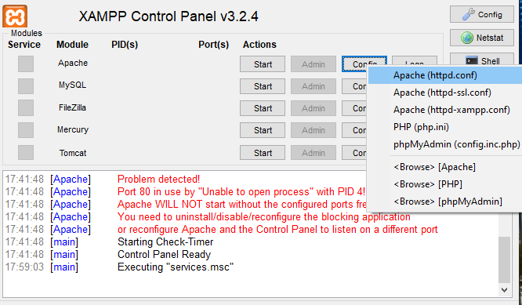

* Find and replace port 80 with 8080:

**Find this**

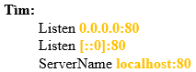

**Then replace it into this:**

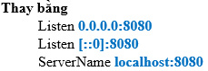

*\*Remember to save the file*

- Sign of success:

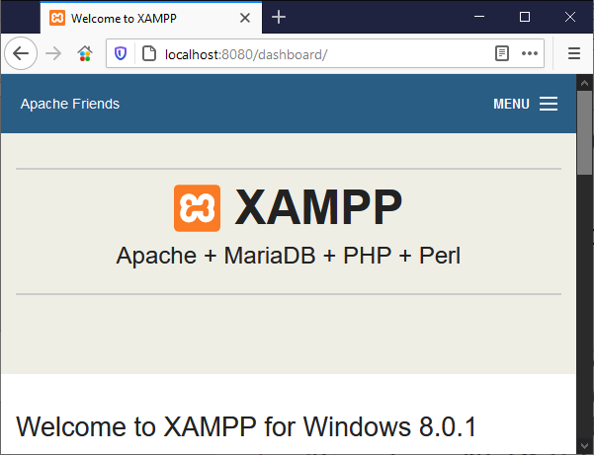

*\*\*****This is optional if you want to change PHP root folder:***

+ Find DocumentRoot in file httpd.conf then replace with the new root folder you like :

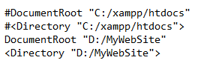

Explain: **+ “C:/xampp/htdocs” is default PHP root folder**

**+ “D:/MyWebsite” is new PHP root folder**

**Step 2. Clone Project to your Computer**

* Open PHP root folder with Git Bash

*\*In this case I use default root folder*

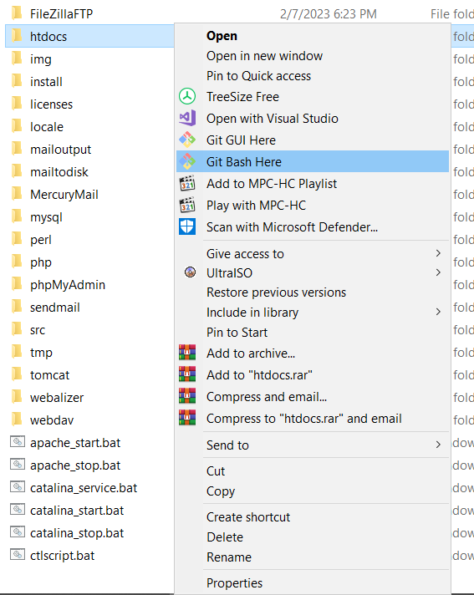

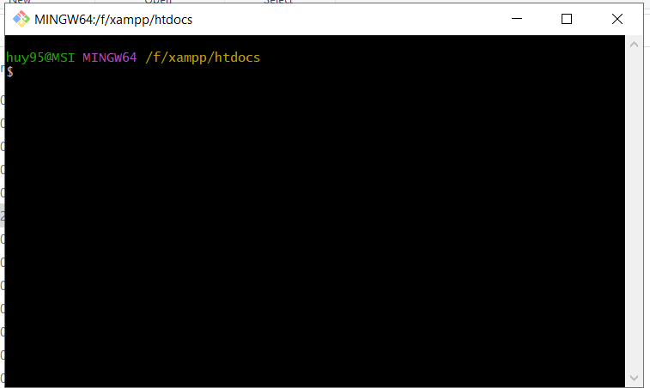

*\*Double check the PHP root folder*

* **Clone the project with syntax like this:**

|  |
| --- |
| git clone https://github.com/nguyendihnam/Group4.git |

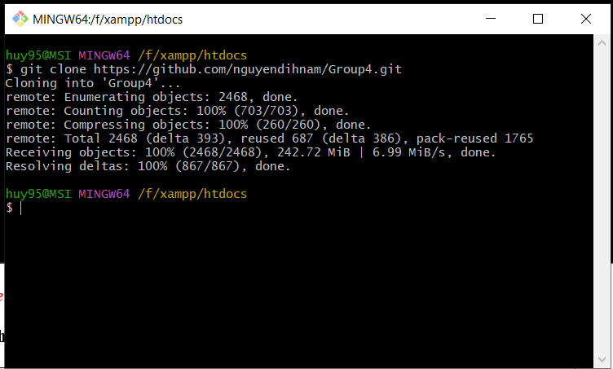

* If you do it right, you will found it in PHP root folder:



**Step 3 . Setup database**

*- In* ***XAMPP*** *Control Panel, click* ***start*** *button Apache and MySQL*

*- Click* ***Admin*** *button to open* ***MySQL****.*

**

- *Create* ***database coffeeshopdb*** *in phpMyAdmin with* ***syntax***

|  |
| --- |
| CREATE DATABASE coffeeshopdb |

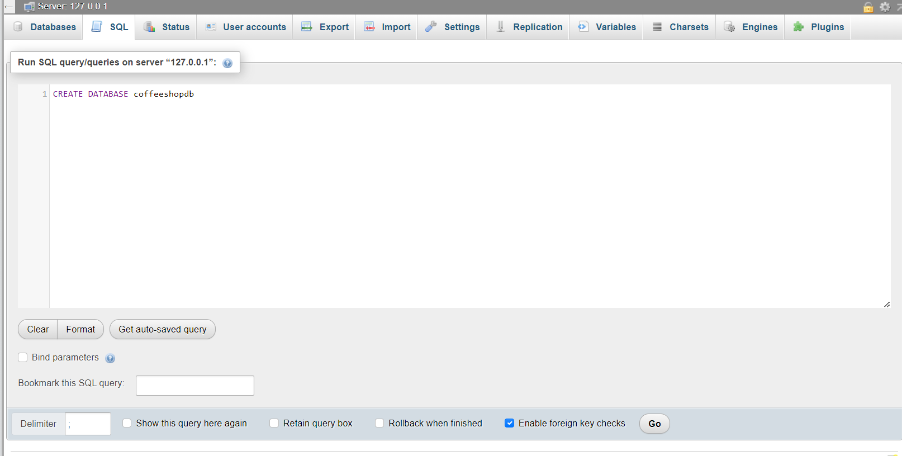

**-** Press **Alt + Enter** to commit create database



- Click on **coffeeshopdb** just created and find **Import** on the top menu bar

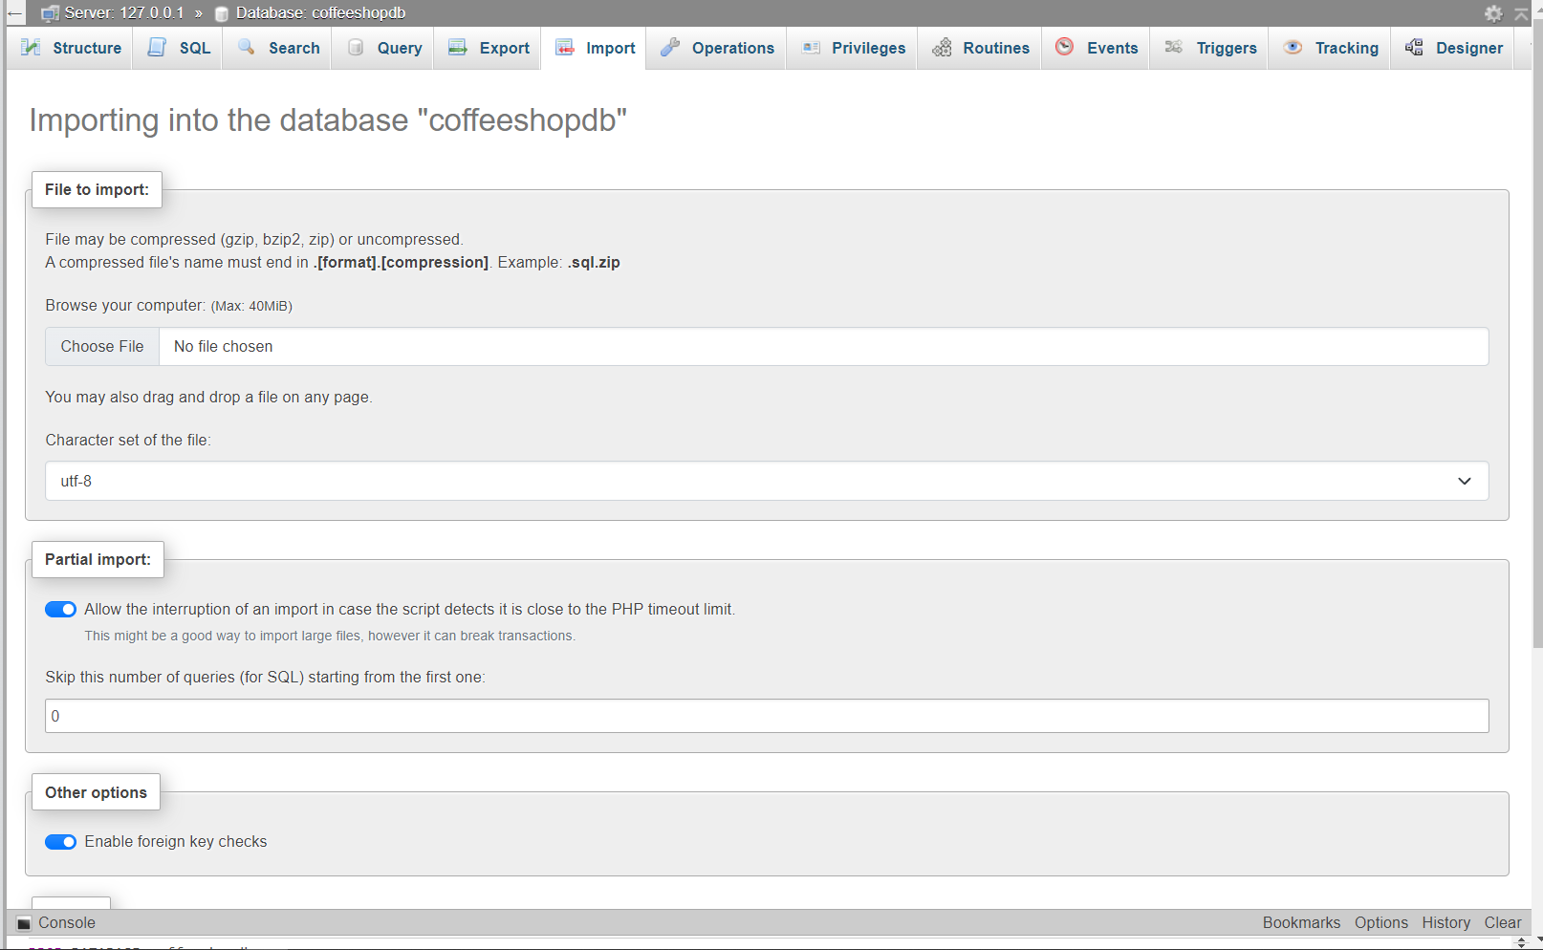

- Choose file **Coffeeshopdb.sql** in folder **Database** and then click button

**Import** at the end of the screen to finish

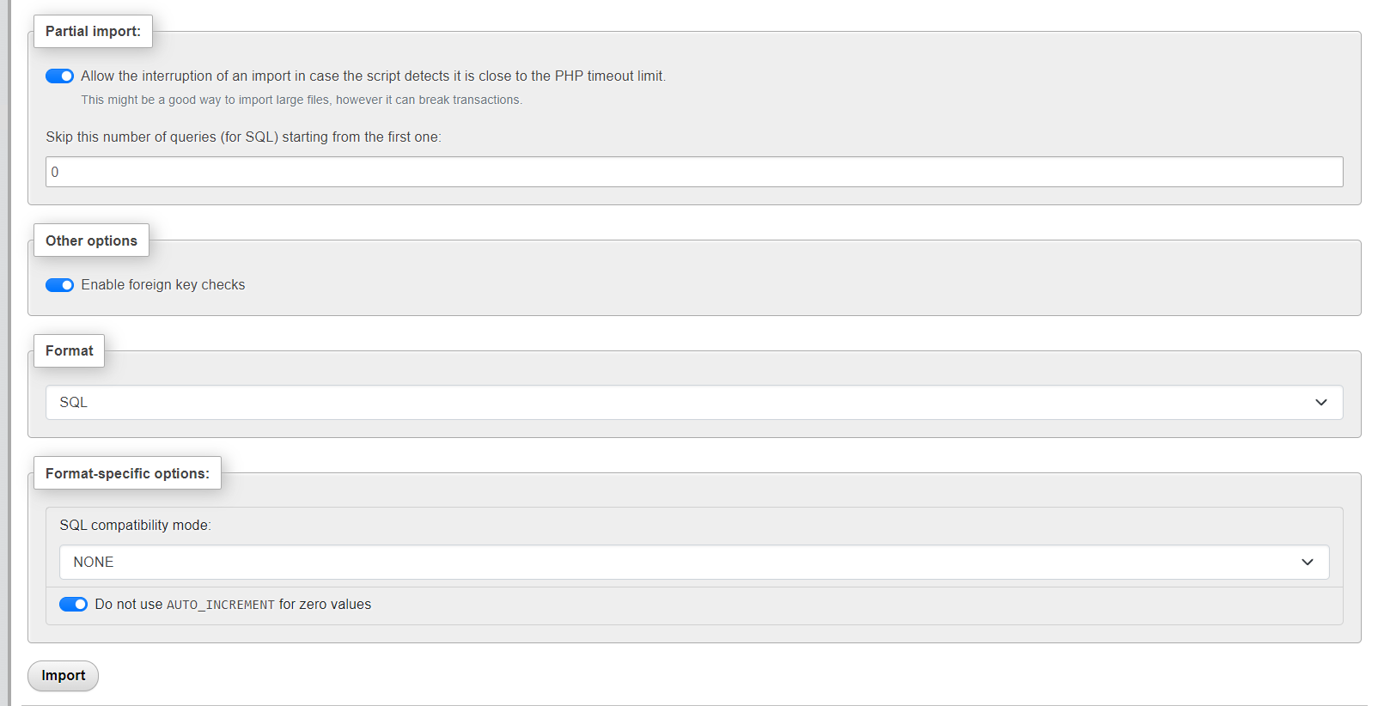

**Step 4. Open URL**

|  |
| --- |
| **http://localhost:8080/Group4/coffee-shop-website-design-main/** |

# C. Successful test

- The website is loaded successfully.

